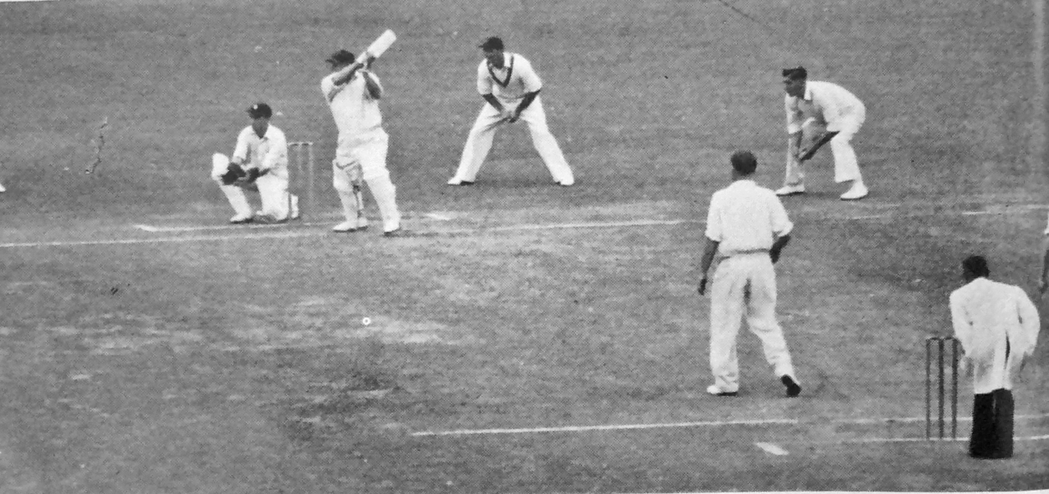

**Canterbury v MCC 8 March 1955 Lancaster Park. Tom Burtt facing Johnny Wardle in his last over of first class cricket.**

**Burtt made 30 not out scoring 6, 4, 0, 6, 4, 4 off the over.**